***Case Study 13.1: FCL Comparison: Automation vs autoISF***

One month FCL using Automations:

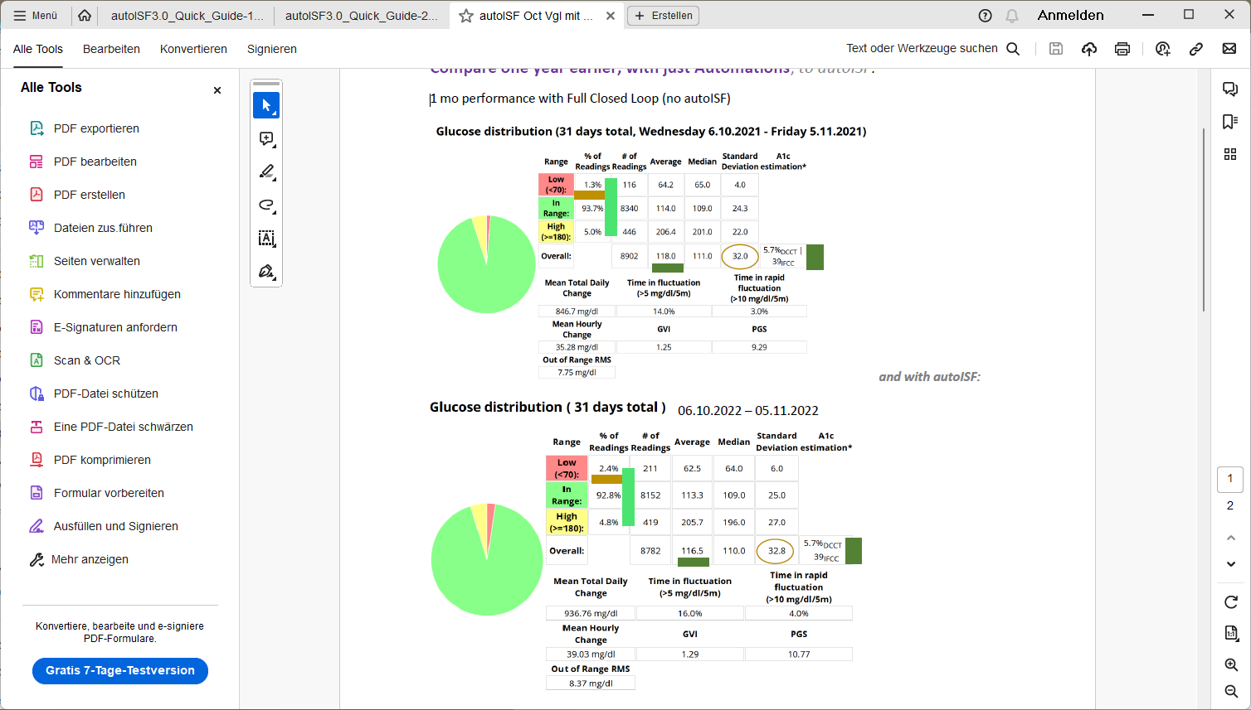

One month FCL using autoISF:



Automation results are for a month, after being 1 year in that mode. autoISF results are from 1 month after being 9 month in that mode.

So both were tuned; however, autoISF is so complicated to tune that I stopped when it deemed good-enough, which 93% TIR certainly is. (Note that, in both cases, these 93%-94%TIR „accomodate“ the occasional day with TIR around 80% because of a not immediately detected occlusion!). While Automations can be clearly directed at time-windows where meals occur, autoISF (at that time, 2022) is burdened by it applying uniformly to 24 hrs, unless an un-even TT is set to shut-off SMBs temporarily.

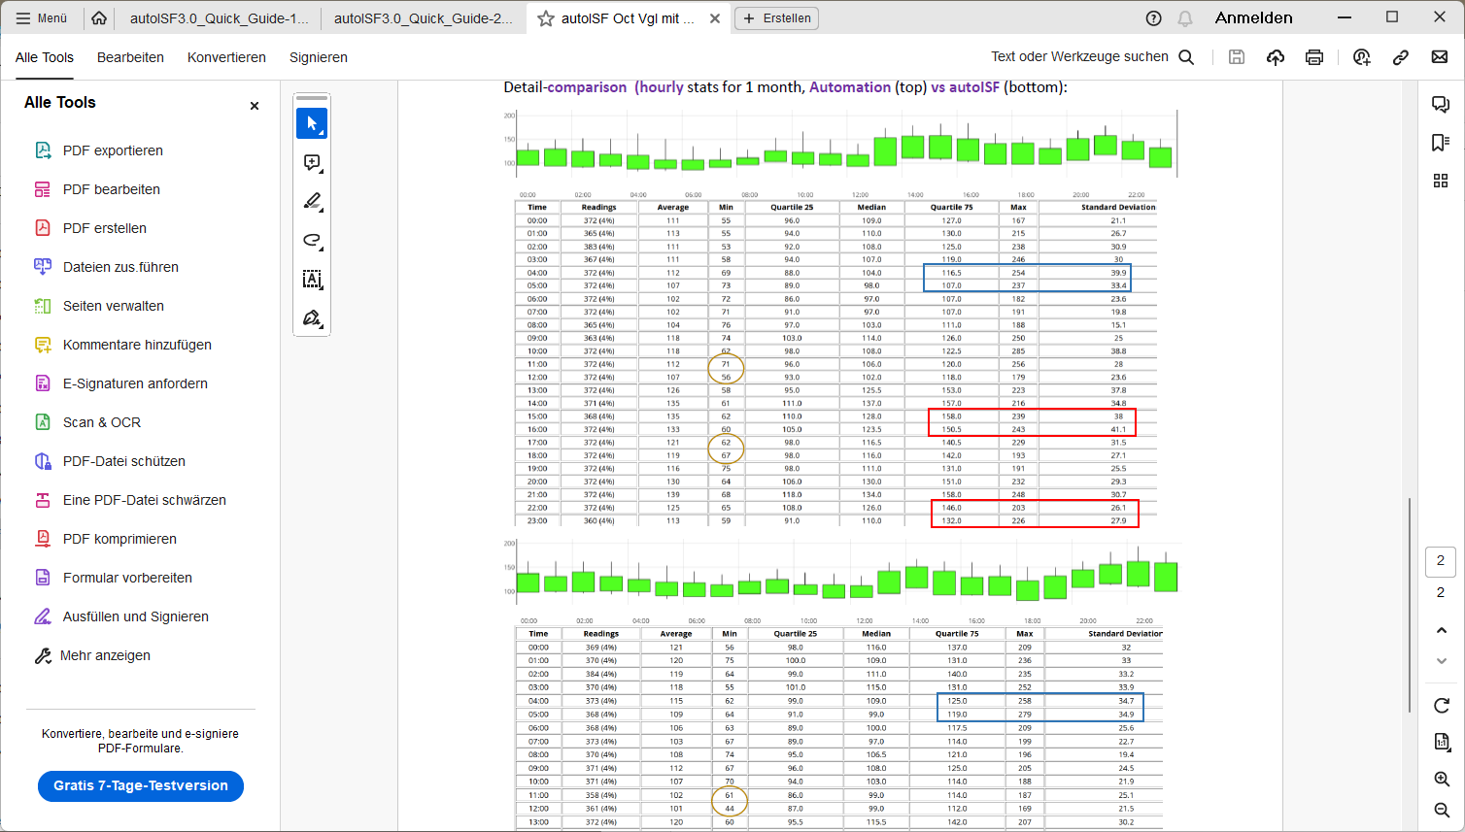

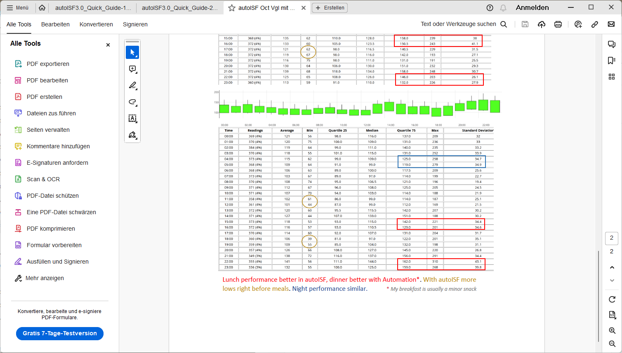

**Conclusion**

FCL with Automations can be a comparably good solution to autoISF.

The latter is more adjustable, especially towards higher SMB sizes that may be needed, for instance by users with richer diets, or with smaller hourly basal.

But for many users the easier Automation route might yield good enough results, notably with low to medium carb diets, while sharply reducing the risks from not optimal settings in autoISF.